SIMATS ENGINEERING
ASSESSMENT TOOL 1

COURSE CODE: CSA51 COURSE NAME: Cryptography and Network Security

COURSE OUTCOME COVERED

CO4: Implement best security practices for IP, email, and web service using PGP, S/MIME for enhancing email Security.CO (BL3, BL6)

Assessment Tool Weightage: 40%

QUESTIONS: 5 TOTAL MARKS: 25

Annexure A
Coding Challenge

Code of Conduct:

I S . Dharshansrinath (192521216) (Name / Reg No) certify that this submission is my original work and that I have adhered to the guidelines specified for this assessment.
I understand that any violation of academic integrity rules will result in disciplinary action.

Signature of the student:

Annexure A
Coding Challenge

4.Implement a simplified Pretty Good Privacy (PGP) system for secure email communication using public key encryption and digital signatures.

ALGORITHM:

Algorithm : PGP System
- Start
- Read the sender email, receiver email, and message.
- Generate or define a public key and private key.
- Create a digital signature for the message using the private key.
- Encrypt the message using the public key.
- Send the encrypted message along with the digital signature.
- At the receiver side, decrypt the message using the corresponding key.
- Verify the digital signature using the public key.
- If the signature is valid, display “Digital Signature: VALID”.
- Otherwise, display “Digital Signature: INVALID”.
- Display the decrypted message.
- Stop.

CODE:

import hashlib
import base64
# Simple key pair
public_key = 17
private_key = 5
def encrypt(message):
data = message.encode()
encrypted = bytes((b + public_key) % 256 for b in data)
return base64.b64encode(encrypted).decode()
def decrypt(ciphertext):
encrypted = base64.b64decode(ciphertext)
decrypted = bytes((b - public_key) % 256 for b in encrypted)
return decrypted.decode()
def sign(message):
return hashlib.sha256(
(message + str(private_key)).encode()
).hexdigest()

def verify(message, signature):
return sign(message) == signature

# Input
sender = input("Enter sender email: ")
receiver = input("Enter receiver email: ")
message = input("Enter email message: ")

# Digital signature
signature = sign(message)

# Encrypt message
encrypted_message = encrypt(message)

print("\n--- PGP Secure Email ---")
print("Sender:", sender)
print("Receiver:", receiver)
print("Encrypted Message:", encrypted_message)
print("Digital Signature:", signature)
# Receiver decrypts
decrypted_message = decrypt(encrypted_message)

print("\n--- Receiver Side ---")
print("Decrypted Message:", decrypted_message)

# Verify signature
if verify(decrypted_message, signature):
print("Digital Signature: VALID")
else:
print("Digital Signature: INVALID")

INPUT:

Enter sender email: alice@gmail.com
Enter receiver email: bob@gmail.com
Enter email message: Hello Bob, this is a secure email.

OUTPUT:

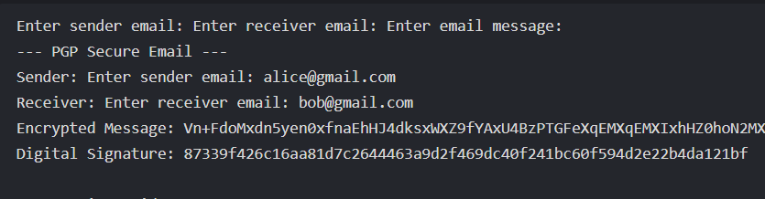

5.Create a program to classify emails as spam or legitimate using email header analysis and content-based filtering techniques.

ALGORITHM:

Algorithm : Spam Email Classification
- Start
- Read the email sender address, subject, and message body.
- Initialize the spam score to 0.
- Analyze the email header:
  - Check the sender address.
  - If the sender appears suspicious or unknown, increase the spam score.
  - Check whether the sender domain is suspicious.
- Analyze the email subject and body.
- Search for common spam words such as “free”, “winner”, “prize”, “urgent”, “offer”, and “click here”.
- Increase the spam score for each detected spam word.
- Check for suspicious patterns such as excessive exclamation marks.
- Compare the final spam score with the threshold.
- If the score is greater than or equal to the threshold, classify the email as SPAM.
- Otherwise, classify it as LEGITIMATE.
- Display the spam score and classification.
- Stop.

CODE:

def classify_email(sender, subject, body):

score = 0

# Header analysis
if "unknown" in sender.lower():
score += 2

if not sender.lower().endswith(
("gmail.com", "yahoo.com", "outlook.com")
):
score += 1

# Content analysis
spam_words = [
"free",
"winner",
"prize",
"lottery",
"urgent",
"click here",
"offer",
"money",
"congratulations"
]

text = (subject + " " + body).lower()

for word in spam_words:
if word in text:
score += 1

# Excessive exclamation marks
if "!!!" in text:
score += 2

# Classification
if score >= 3:
return "SPAM", score
else:
return "LEGITIMATE", score

# Input
sender = input("Enter sender email: ")
subject = input("Enter email subject: ")
body = input("Enter email body: ")

result, score = classify_email(
sender,
subject,
body
)

print("\n--- Email Analysis ---")
print("Sender:", sender)
print("Subject:", subject)
print("Spam Score:", score)
print("Classification:", result)

INPUT:
Enter sender email: unknown@spam.com
Enter email subject: Congratulations! You won a prize!!!
Enter email body: Click here to claim your free money.

OUTPUT:

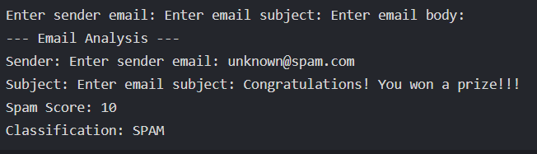

RUBRICS FOR CALCULATION:

Criteria | Weightage | Level 4 (Exemplary) | Level 3 (Proficient) | Level 2 (Developing) | Level 1 (Beginning)
Problem Understanding | 20% | Clearly understands problem constraints, edge cases, and competitive requirements | Understands problem with minor gaps in constraints | Partial understanding; misses key constraints | Misinterprets problem or constraints
Algorithm | 25% | Selects optimal algorithm with best time and space complexity for competitive constraints | Uses efficient algorithm with minor scope for improvement | Uses basic/inefficient approach | No clear algorithmic approach
Code Implementation | 20% | Writes correct, efficient, and clean code that passes all constraints | Code works with minor errors or inefficiencies | Partially correct code; fails for some cases | Code does not execute or gives incorrect results
Competitive Performance | 20% | Solves problem within time limits and handles large inputs effectively | Solves within acceptable time with minor delays | Struggles with time limits or larger inputs | Unable to solve within time constraints
Test Case Handling | 15% | Handles all test cases including edge and hidden cases | Handles most test cases | Misses important edge cases | Fails on multiple test cases

